Name of Student : Raghav Mahesh Sarda PRN: 25070122235
Subject: Programming with Java Semester: III
ASSIGNMENT No : 14 Year: AY 2026-27
TITLE : Exception Handling using Try-Catch

Problem Statement
Write a Java program to demonstrate exception handling using try and catch blocks, nested and multiple try-catch blocks.

Learning Objectives
To handle runtime exceptions using try-catch, nested try, and multiple catch blocks.

Program:
MultiCatch.java
// Assignment 14 - Exercise 1: Exception handling with Multiple Catch Blocks
import java.util.*;
public class MultiCatch
{
public static void main(String args[]) // Main method
{
Scanner sc = new Scanner(System.in); // Scanner object
int arr[] = {10, 20, 30, 40, 50}; // Initializing sample array
System.out.println("Sample Array:");
for(int i=0; i<5; i++)
{
System.out.print(arr[i]+" ");
}
System.out.println("\n");
try
{
System.out.print("Enter index to access (0-4): ");
int idx = sc.nextInt(); // Reading index
System.out.println("Array value at index " + idx + " is: " + arr[idx]); // Accessing array element

System.out.print("Enter divisor for the value: ");
int div = sc.nextInt(); // Reading divisor
int res = arr[idx] / div; // Arithmetic division
System.out.println("Division Result = " + res); // Printing quotient
}
catch(ArrayIndexOutOfBoundsException e) // Catching invalid index
{
System.out.println("Error: Index entered is beyond array limits!"); // Handling array exception
}
catch(ArithmeticException e) // Catching division by zero
{
System.out.println("Error: Division by zero is not allowed!"); // Handling math exception
}
catch(Exception e) // Generic exception fallback
{
System.out.println("Error: Exception occurred! " + e.getMessage()); // Generic message
}
System.out.println("Program execution continues normally.");
sc.close();
System.out.println("\n");
}
}

NestedTryCatch.java
// Assignment 14 - Exercise 2: Exception handling with Nested Try-Catch Blocks
import java.util.*;
public class NestedTryCatch
{
public static void main(String args[]) // Main method
{
Scanner sc = new Scanner(System.in); // Scanner object
int nums[] = {100, 200, 300}; // Sample array
System.out.println("Sample Array:");
for(int i=0; i<3; i++)
{
System.out.print(nums[i]+" ");
}
System.out.println("\n");

try // Outer Block
{
System.out.print("Enter array index to divide: ");
int index = sc.nextInt(); // Reading index
int val = nums[index]; // Potentially throws ArrayIndexOutOfBoundsException

try // Inner Block
{
System.out.print("Enter a divisor: ");
int divisor = sc.nextInt(); // Reading divisor
int quotient = val / divisor; // Potentially throws ArithmeticException
System.out.println("Result: " + val + " / " + divisor + " = " + quotient); // Printing result
}
catch(ArithmeticException e) // Handling inner try block exception
{
System.out.println("Inner Catch: Cannot divide by zero!"); // Inner catch error
}
}
catch(ArrayIndexOutOfBoundsException e) // Handling outer try block exception
{
System.out.println("Outer Catch: Selected index does not exist in array!"); // Outer catch error
}
System.out.println("Nested try-catch demonstration finished."); // Completion message
sc.close();
System.out.println("\n");
}
}

Output:
MultiCatch.java
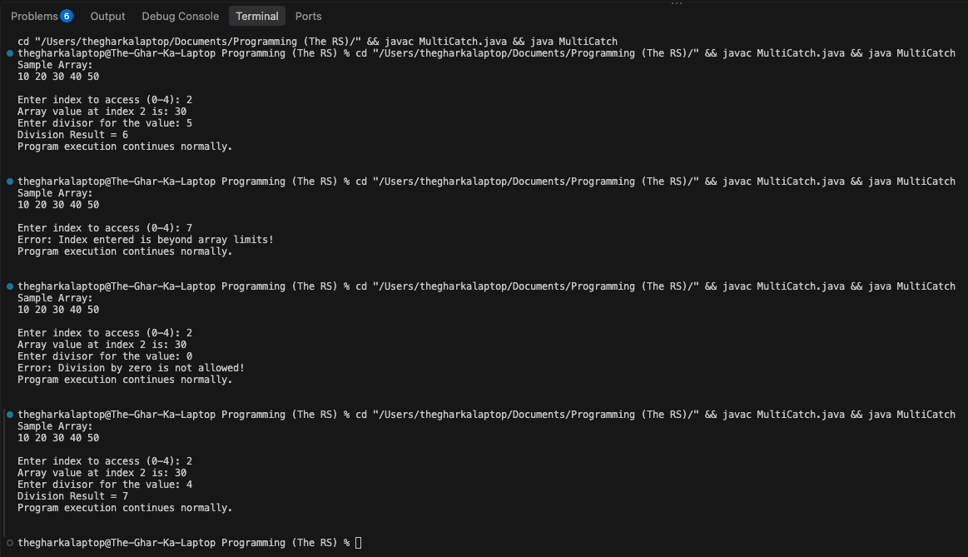
NestedTryCatch.java
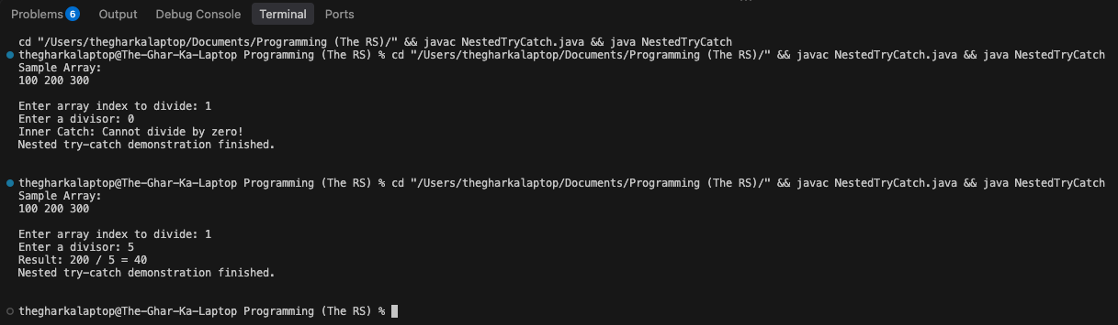

Conclusion:
In this assignment, the concepts of runtime error handling using single, multiple, and nested try-catch blocks were successfully implemented and verified. Multiple catch blocks ensured specific error messages were triggered for distinct runtime faults like division by zero and invalid array indexing, while nested try-catch structures enabled localized exception resolution without interrupting outer code flow.

